**9 - R710 Proxmox VM – Ubuntu with STATIC IP**

**Log in to Proxmox:**

1. In Firefox, go to : https://192.168.124.**201**:8006

User: root

Password : <whatever>

**Storage area for uploading ISO’s into**

1. Download the required Ubuntu Server 64 bit LTS to local PC end then click the “Upload” button to end up with something similar to:  
   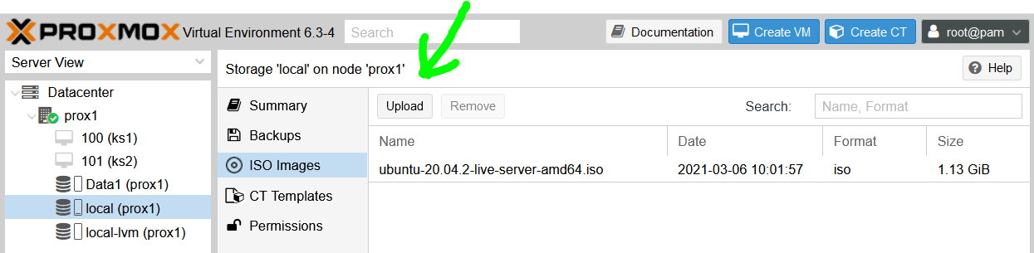

**VM – Full Virtual Machine ( Ubuntu 20.04 LTS )**

1. This example covers a minimal VM for a Kubernetes Server that is part of 3 servers in a cluster.
2. Click “Create VM” and fill in Name, thus (ensure Advanced is ticked):

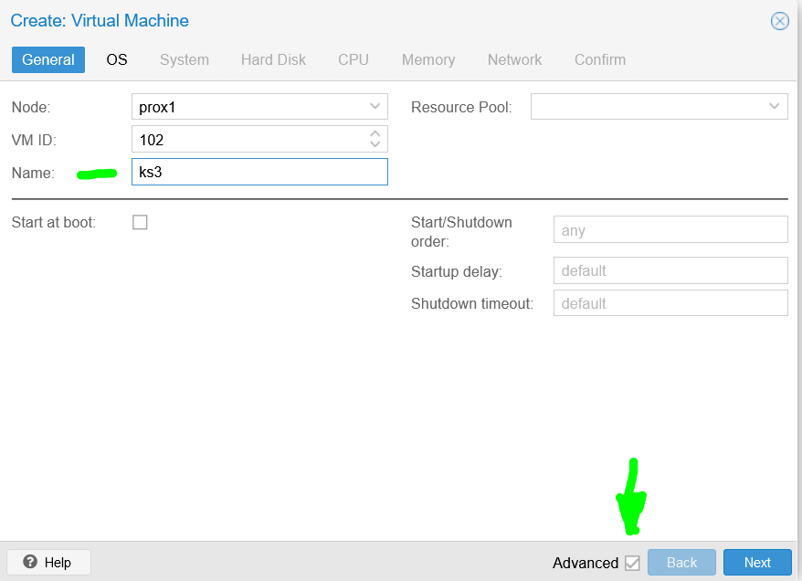

1. Select the ISO image to install from:  
   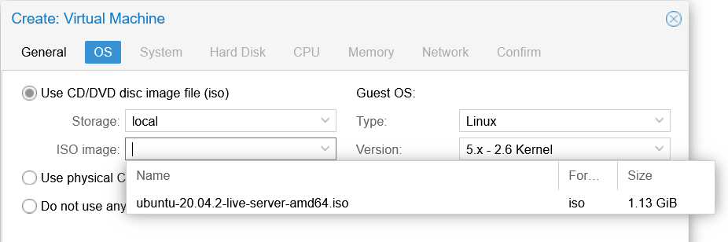
2. Leave System as is:  
   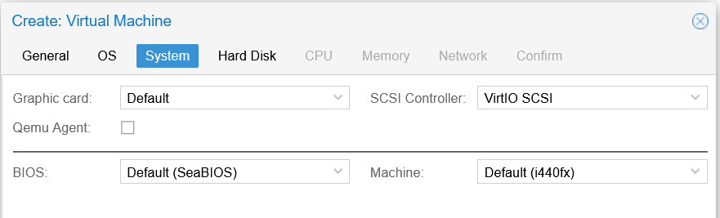
3. Hard Disk, adjust to 20GiB **AND** set storage to be **local-lvm** (Worker VM’s will go in Data1) **AND** set the Bus/Device to **VirtIO** Block (for better Linux performance):  
   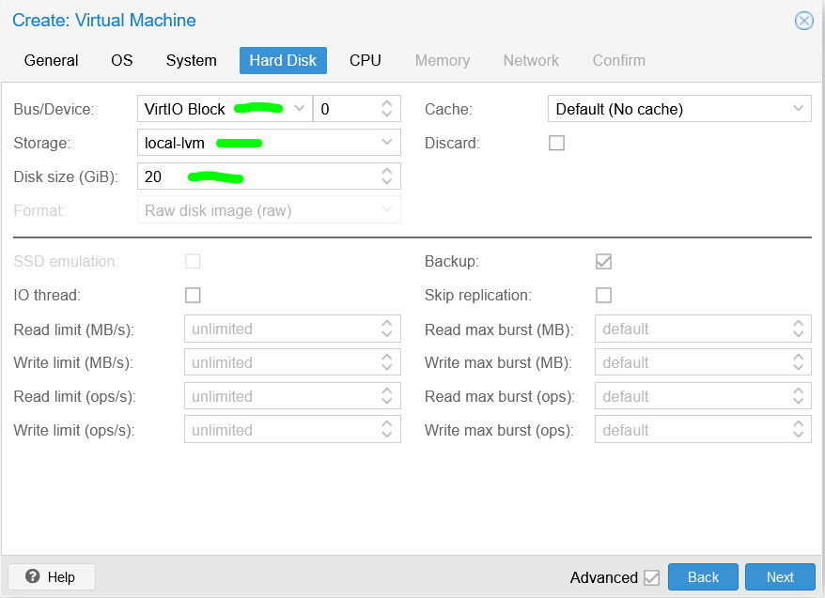
4. CPU, adjust as follows:  
   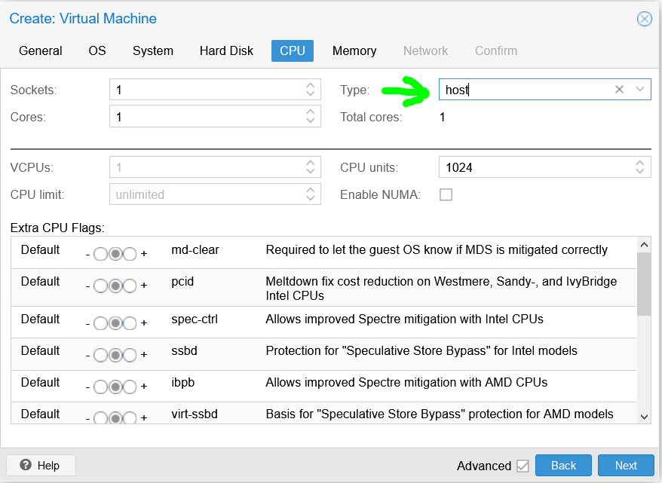
5. Memory, adjust as follows:  
   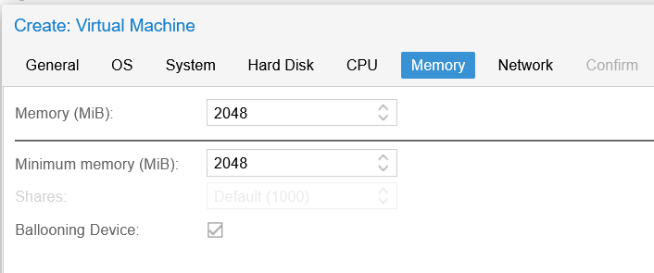
6. Leave Network as is:  
   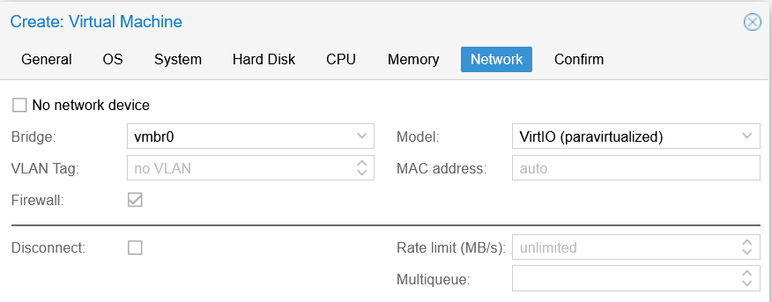
7. And on Confirm, click Finish:  
   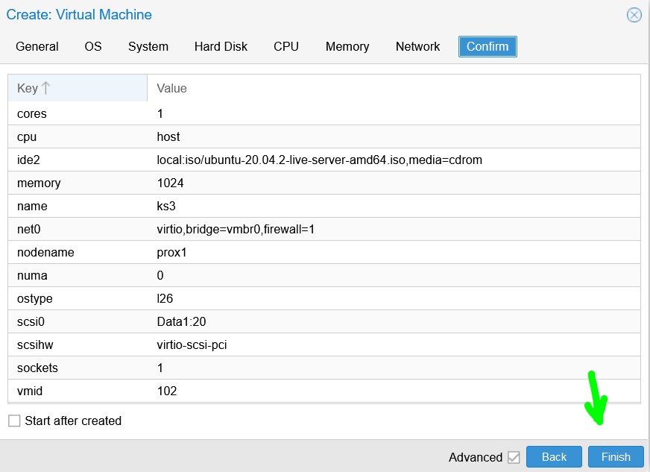
8. Select ks3, click on start and then click on Console:  
   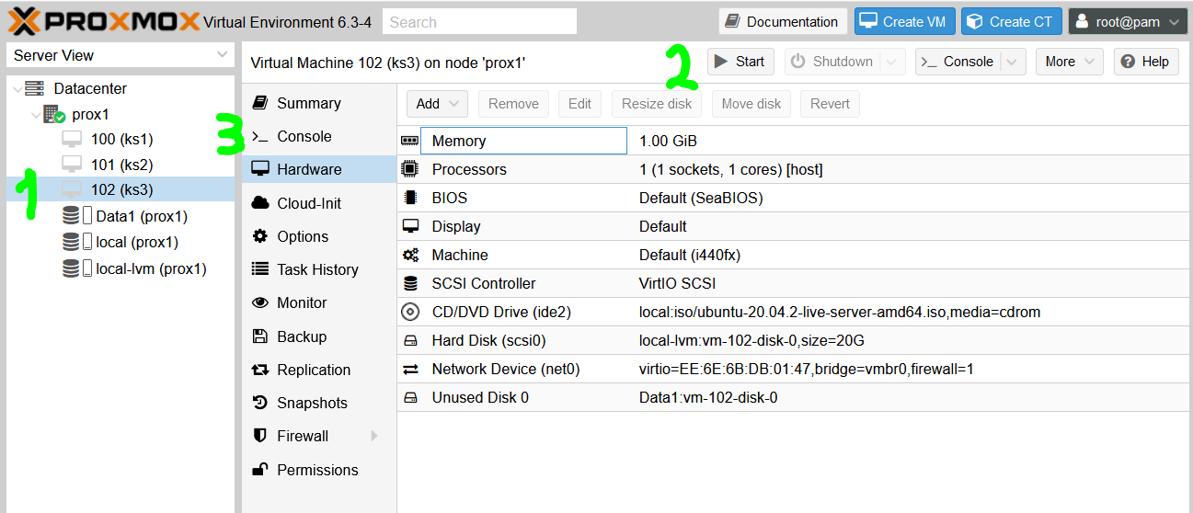
9. Ubuntu will start to install … and gets to the first screen:  
   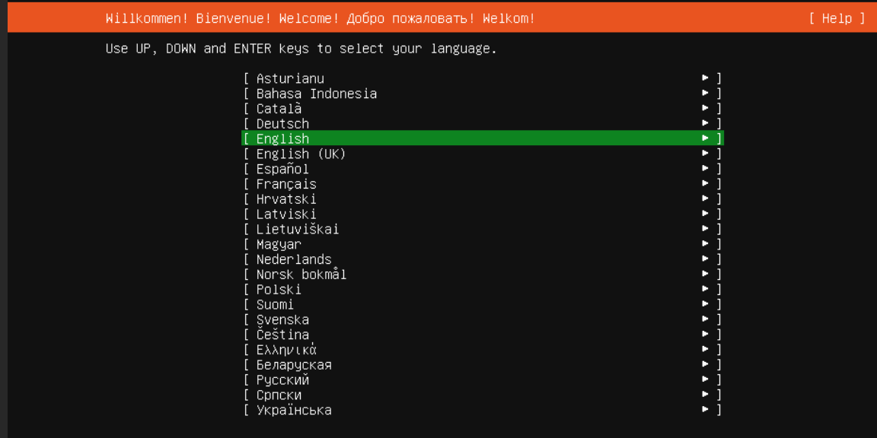
10. Press ENTER, to get:  
    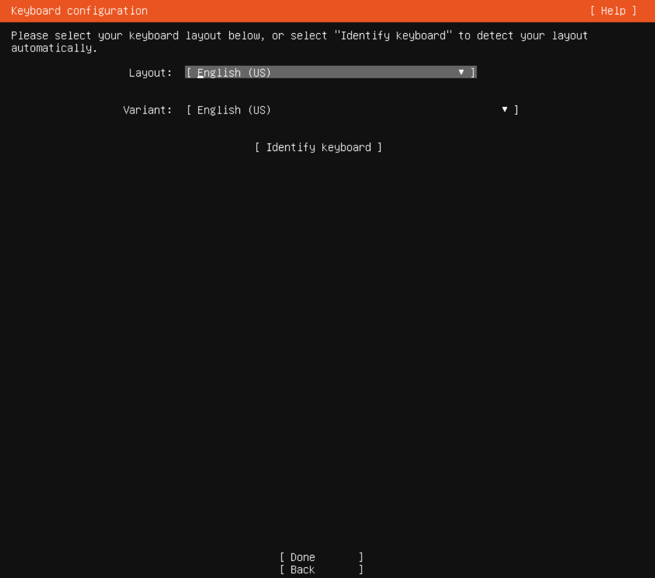
11. TAB to ‘Done’ and press ENTER, to get:  
    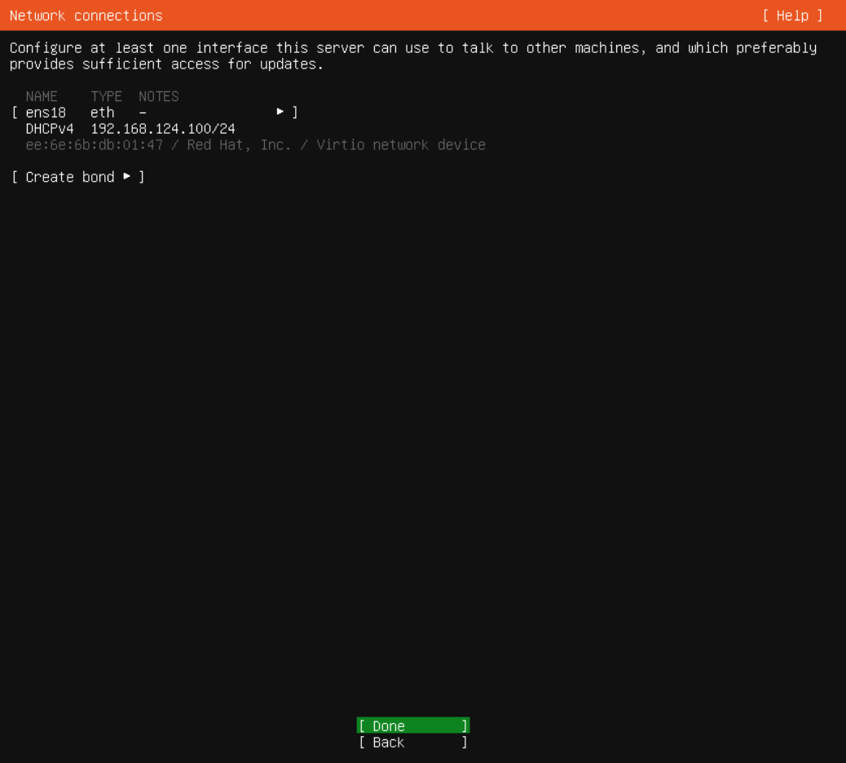
12. Press ENTER, to get:  
    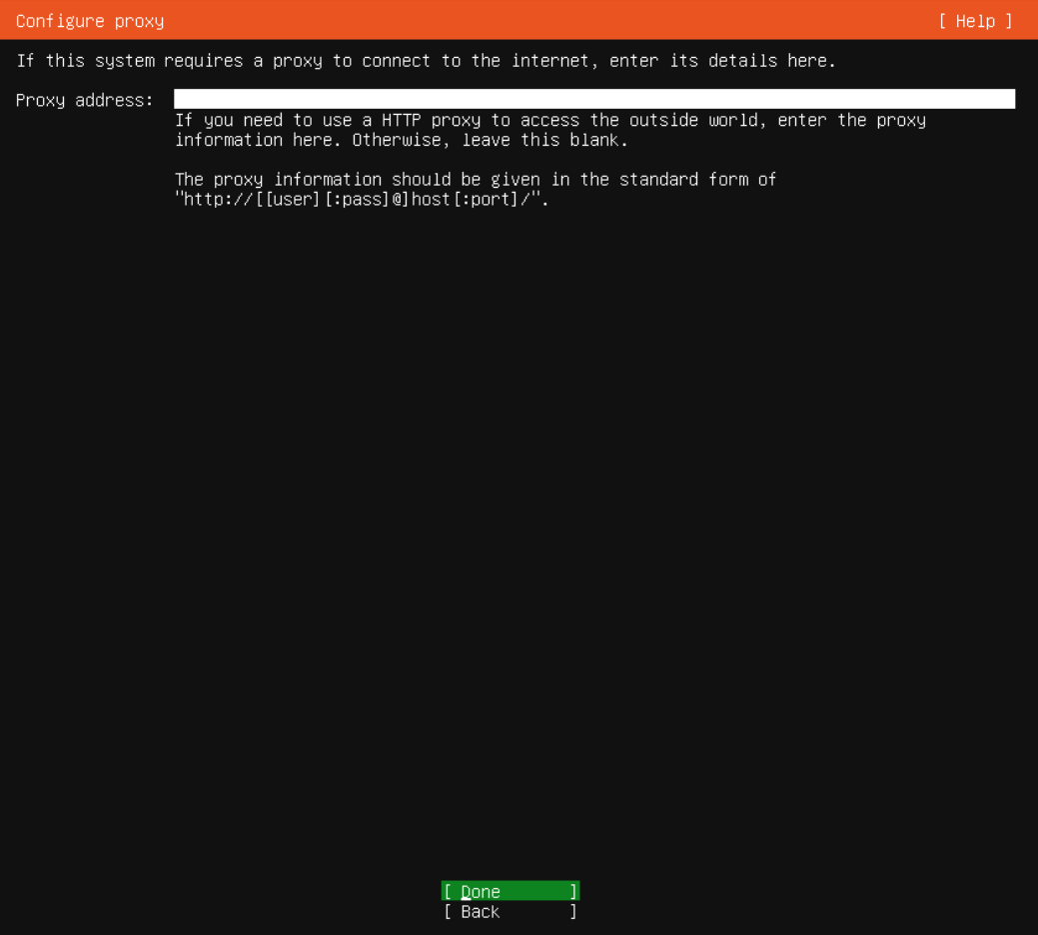
13. Press ENTER, to get:  
    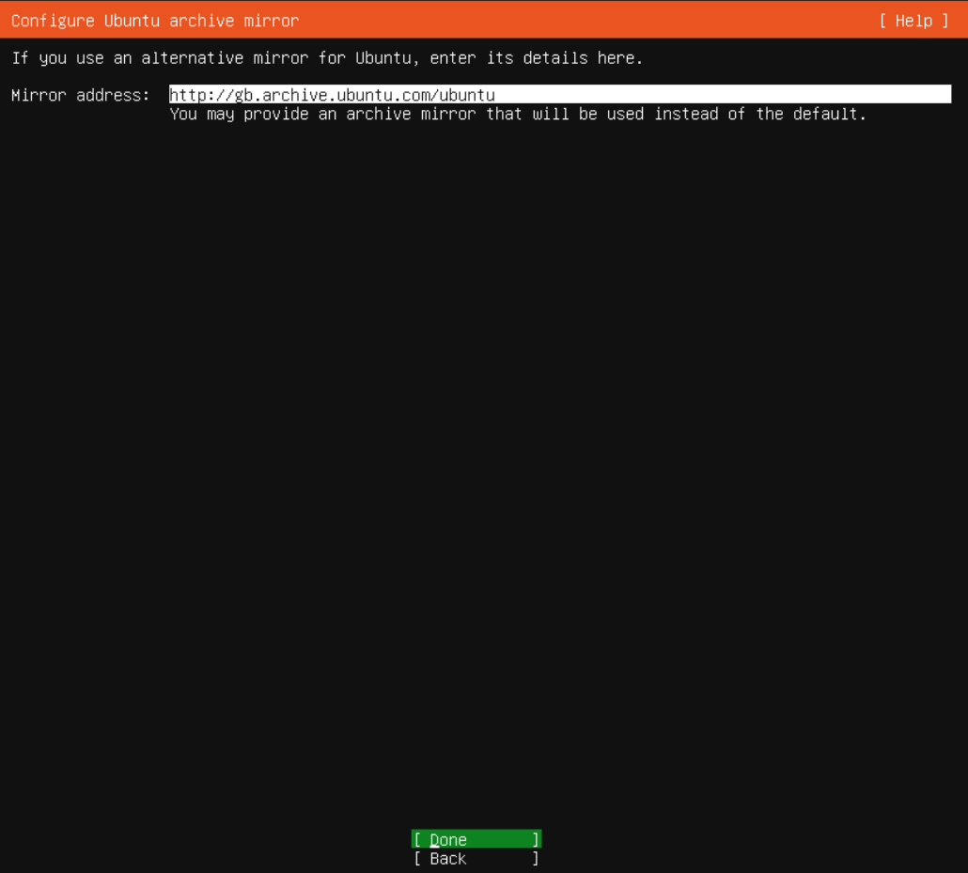
14. Press ENTER to get:  
    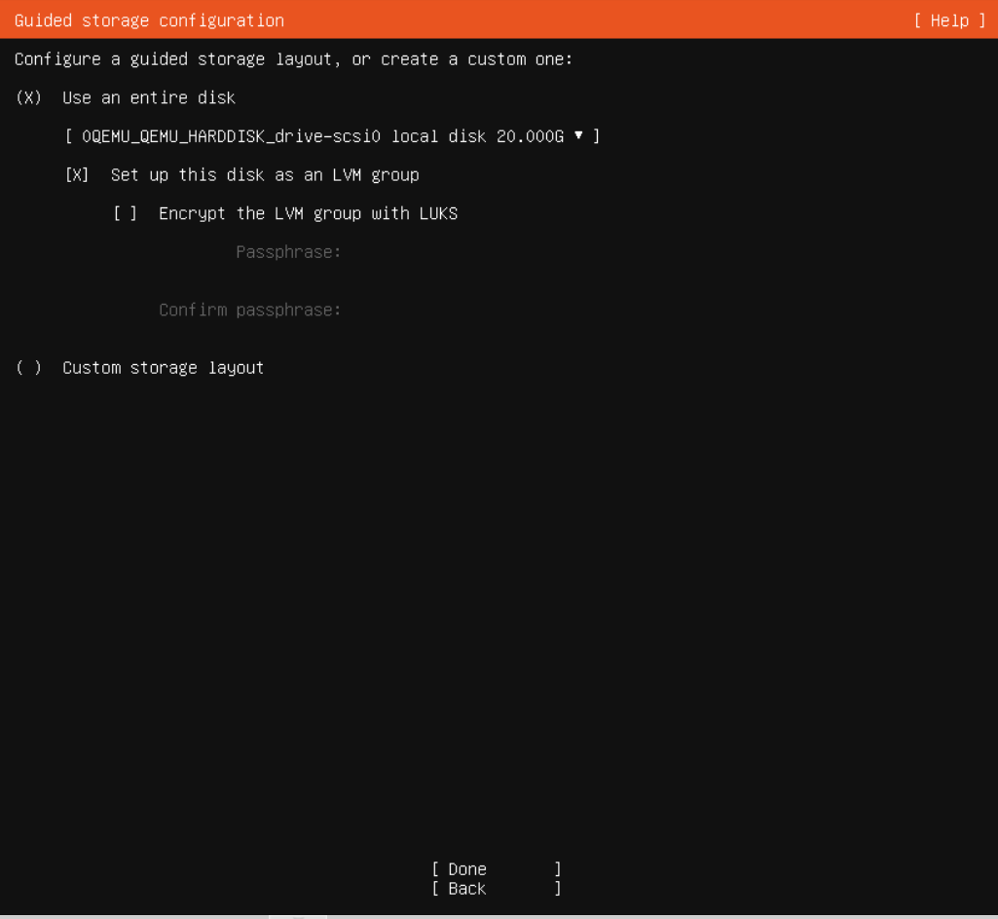
15. Select ‘Done’ and press ENTER, to get:  
    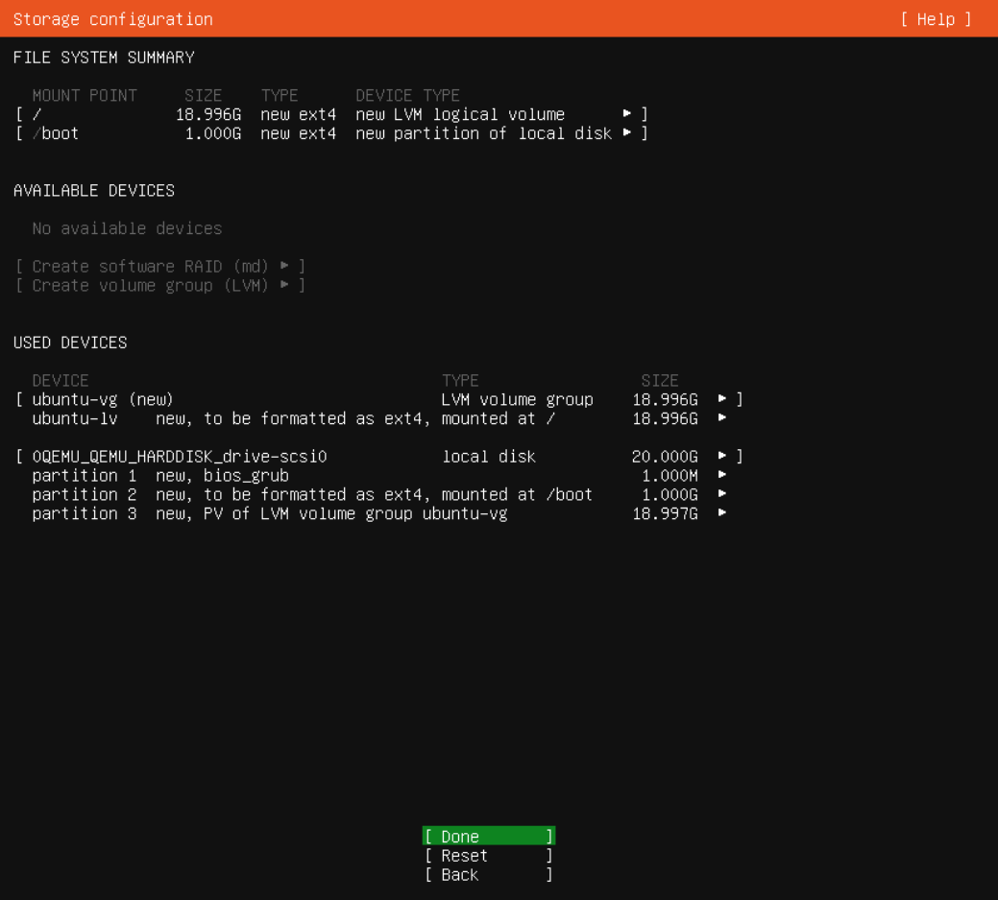
16. Press ENTER, to get:  
    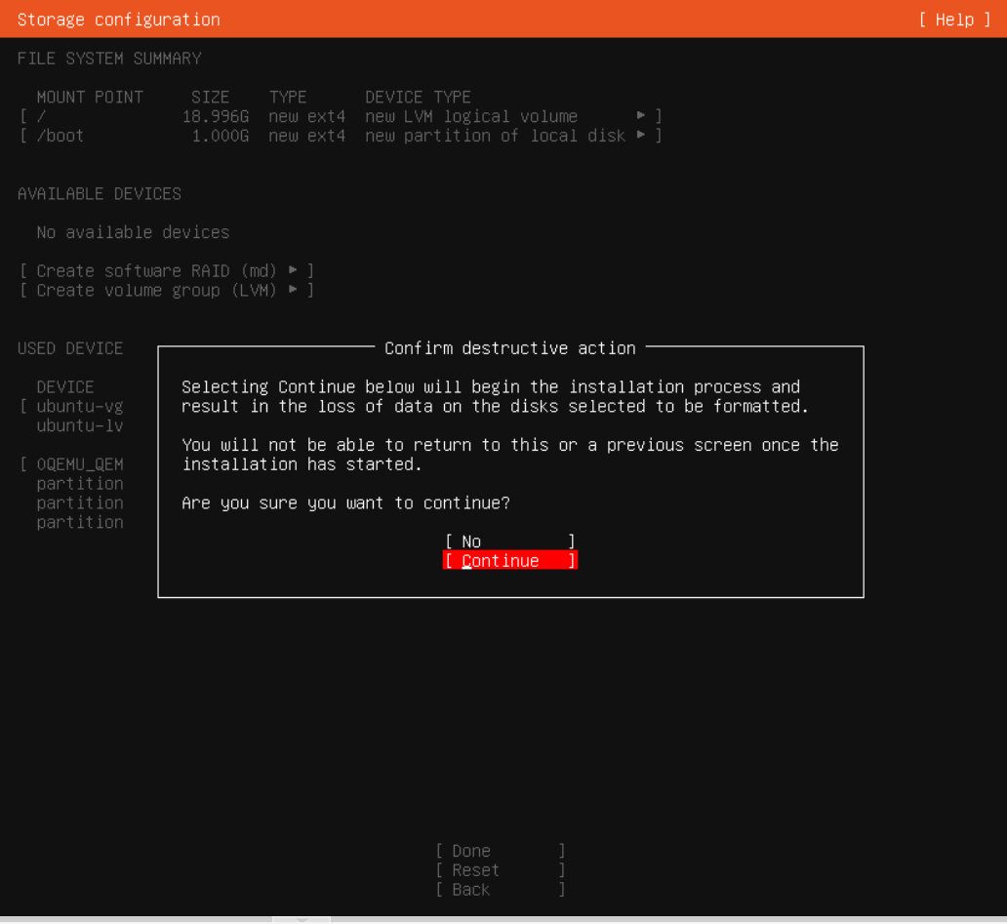
17. Select ‘Continue’ and press ENTER, to get:  
    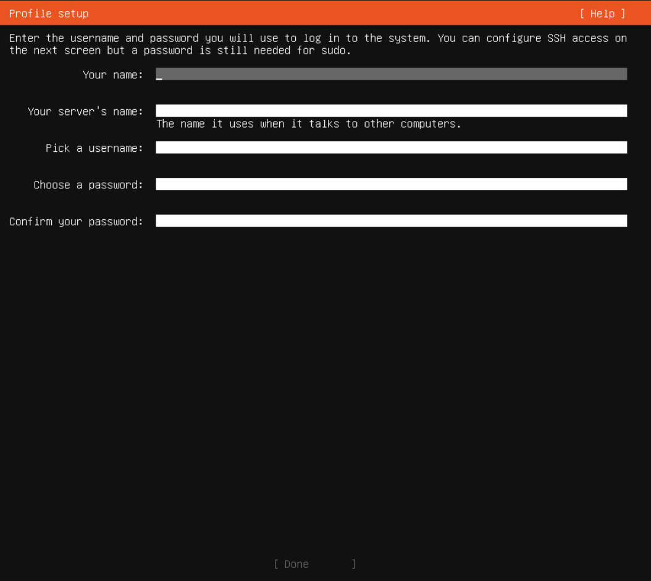
18. Fill in details (in this example set server’s name to: ks3), select ‘Done’ and press ENTER, to get:  
    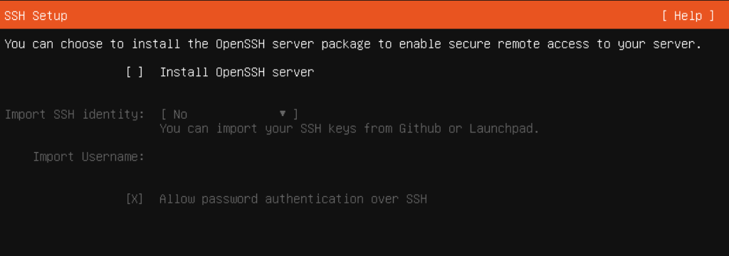
19. Ensure Install OpenSSH server is selected, thus:  
    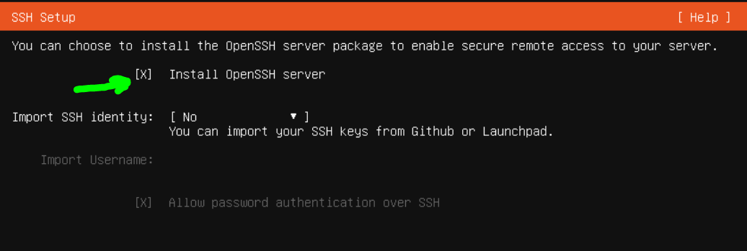
20. Select ‘Done’ and press ENTER, to get:  
    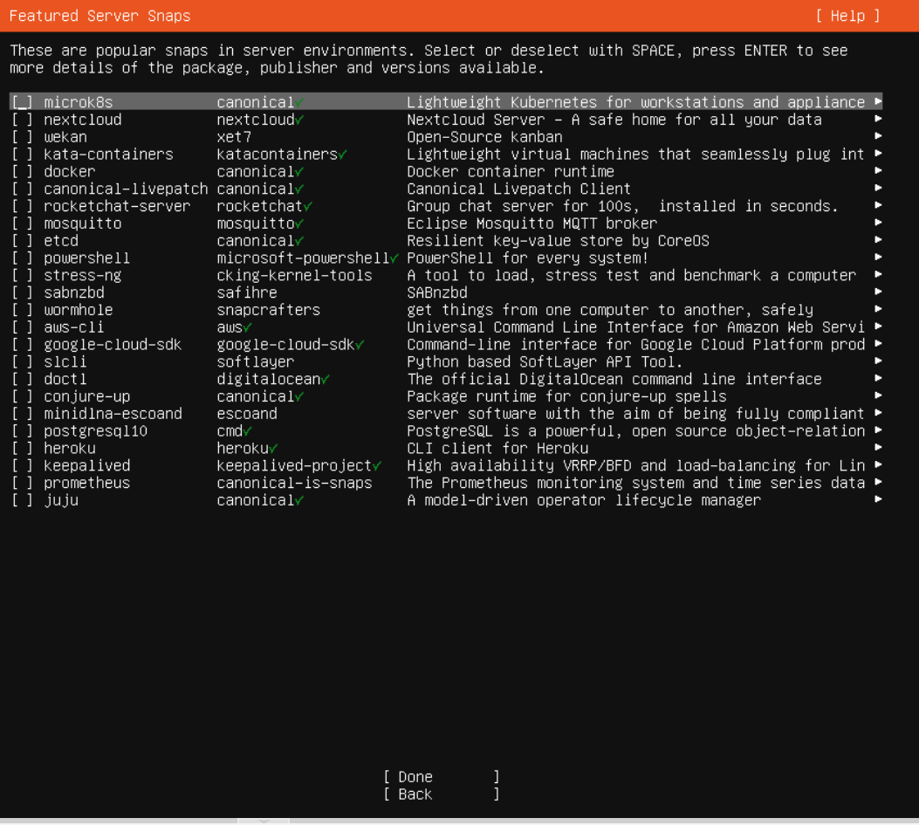
21. Don’t select anything, TAB to highlight ‘Done’, press ENTER, to get:  
    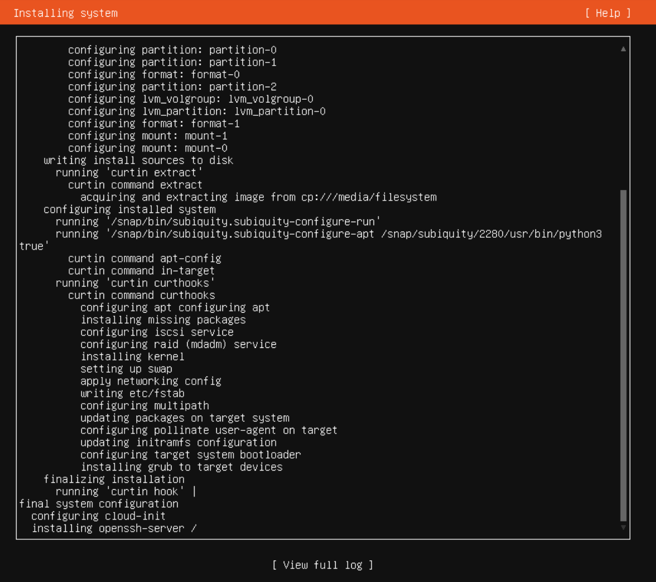
22. The install will now proceed and take ~3 mins, to get:  
    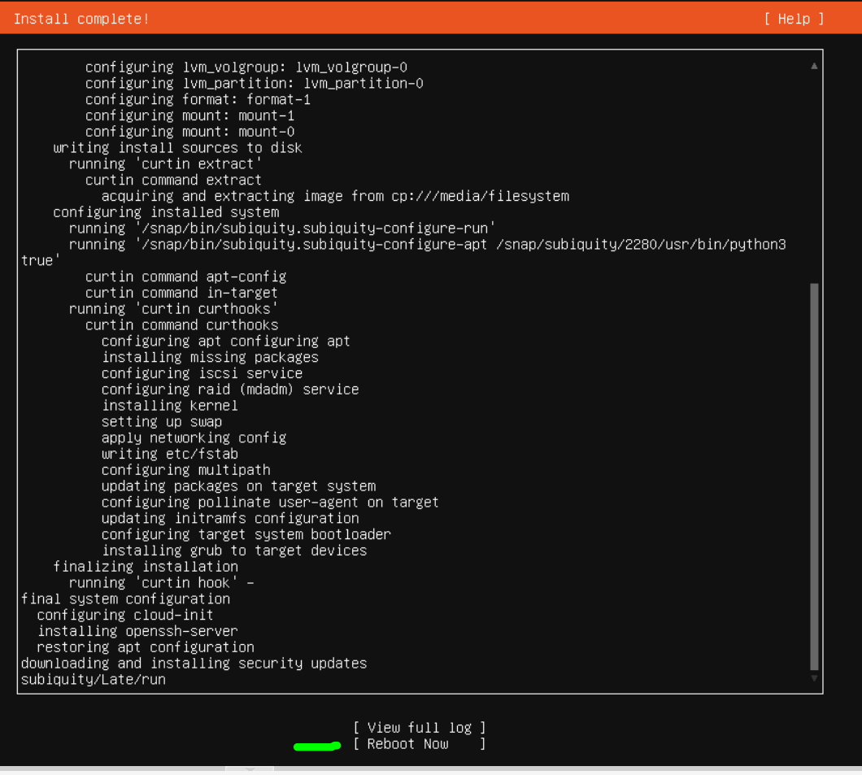
23. Select ‘Reboot Now’ and press ENTER, to get:  
    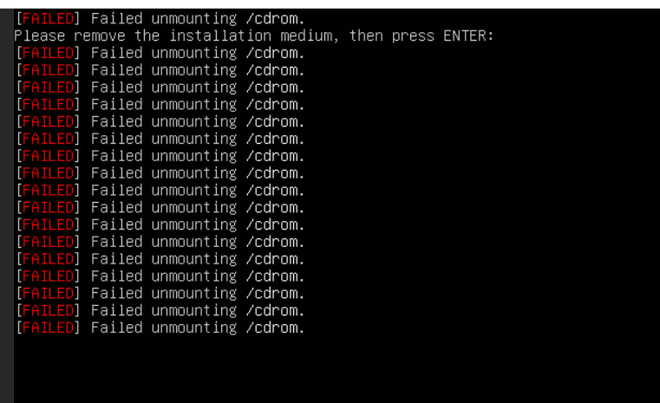
24. Press ENTER, to get a boot where the system does a messy start up that quickly overwrites the prompt for **user** name, thus:  
    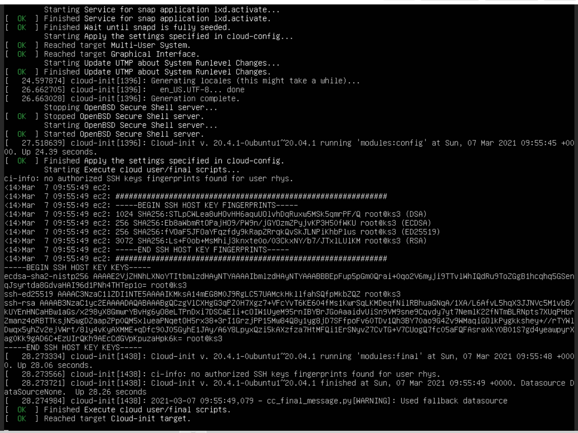
25. Enter **user** name and press ENTER  
    Then enter **password** and press ENTER  
    And you get:  
    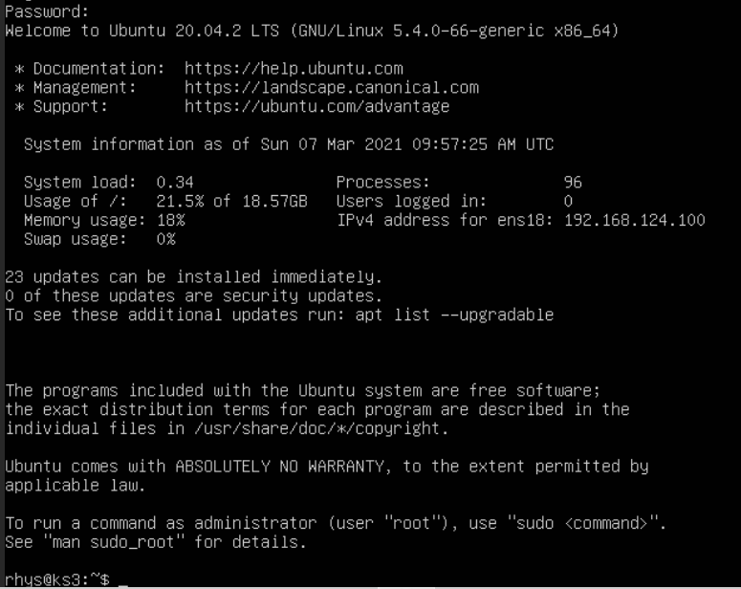
26. The VM stored in the “local-lvm” which is of type LVM-Thin (which does not pre-allocate all of the storage space – it is allocated as needed).
27. Check hostname and hosts:

cat /etc/hostname  
to see: ks3

cat / etc/hosts  
to see: a number of lines, including: 127.0.1.1.ks3

1. Do updates:  
   sudo apt update

sudo apt upgrade -y

sudo apt install net-tools

1. Do:  
   sudo usermod –aG sudo <user name>
2. Log out and back in again for above to take effect.
3. Follow the rest of the instructions below:

-=-=-

**Changing IP address on Ubuntu 20.04 LTS**

Do:

ip add show

to determine the ens<??> port for the following:

In terminal as root, cd into /etc/netplan and make a backup of file first, then edit original file:

**00-installer-config.yaml**

And change it to (BUT for ks3, make the address 192.168.124.204/16 ):

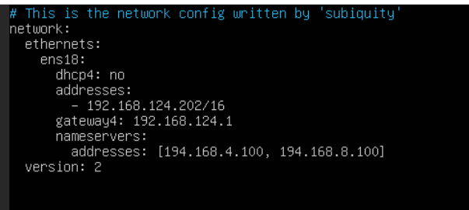

Then do (pay attention to any errors and fix them):

netplan apply

then do:

ip add show dev ens18

or:

ip add show

For more info, see: https://linuxize.com/post/how-to-configure-static-ip-address-on-ubuntu-18-04/

-=-=-

**Docker in VM**

1. To install Docker into the VM, follow Step 1 & 2 at <https://www.digitalocean.com/community/tutorials/how-to-install-and-use-docker-on-ubuntu-18-04>  
   And when you get to the stage of running command:  
   **apt-cache policy docker-ce**  
   it produces something like:  
   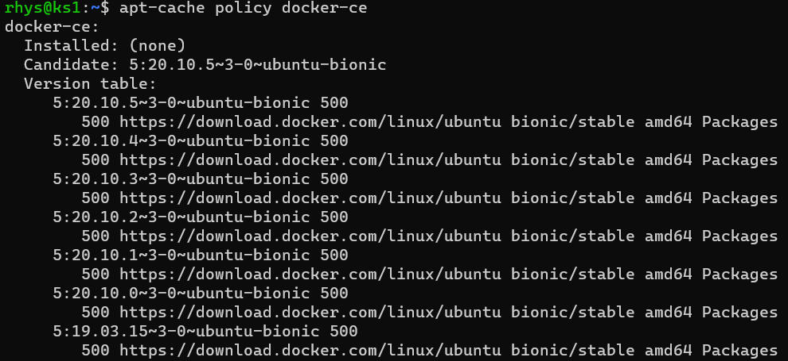
2. Now edit file (to enable IPv4 packet forwarding for kubernetes):  
   sudo nano /etc/sysctl.conf  
   and look for line:  
   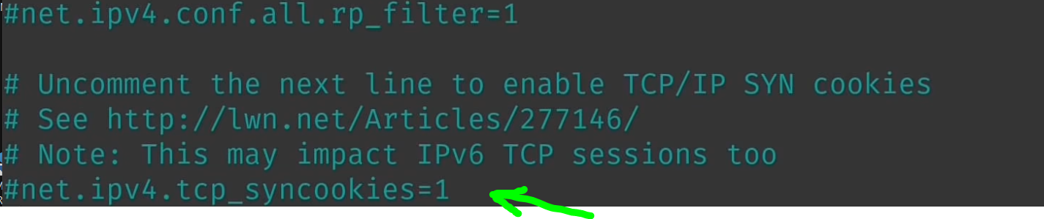  
   and uncomment line to be:  
   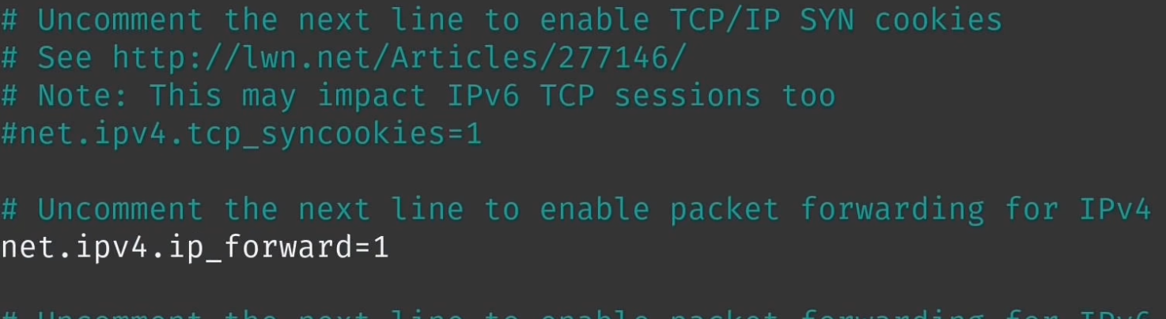  
   and then reboot for changes to take effect.
3. To check Docker is running:  
   systemctl status docker
4. To test Docker:

docker run hello-world



**Cloud init – for cloning VM’s**

1. Then **creating** a template from this with cloud-init, see video:  
    Creating a template in Proxmox Virtual Environment with cloud-init support  
    <https://www.youtube.com/watch?v=8qwnXd1yRK4>
2. The commands to enter from the video:  
     
   sudo apt install cloud-init  
     
   sudo rm /etc/machine-id  
   sudo touch /etc/machine-id  
   cat /var/lib/dbus/machine-id  
   sudo rm /var/lib/dbus/machine-id  
   sudo ln -s /etc/machine-id /var/lib/dbus/machine-id  
   ls -l /var/lib/dbus/machine-id  
    shows:  
   lrwxrwxrwx 1 root root 15 Mar 13 11:12 /var/lib/dbus/machine-id -> /etc/machine-id  
     
   cat /etc/machine-id  
    should return an empty file  
     
   sudo apt clean
3. All the configuration for the virtual machine is now done to allow the creating of a template.
4. Now power off the VM
5. We will now create what is called “a cloud init drive”
6. Goto Hardware/Add/CloudInit Drive:  
   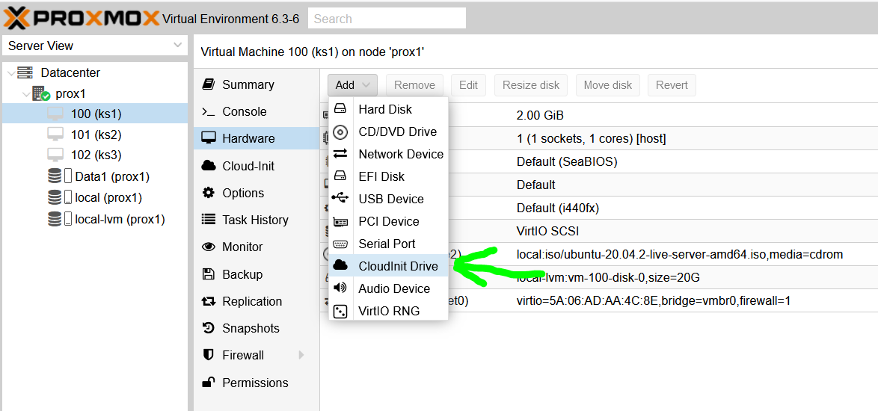  
   to get:  
   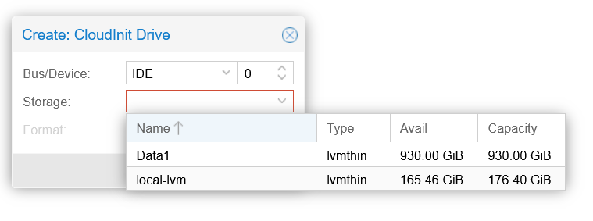  
   and click on **local-lvm**, to get:  
   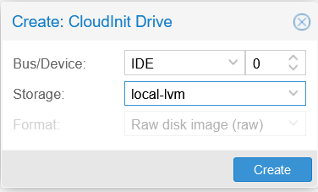  
   and click on Create
7. Now go to this screen, to edit User and Password:  
   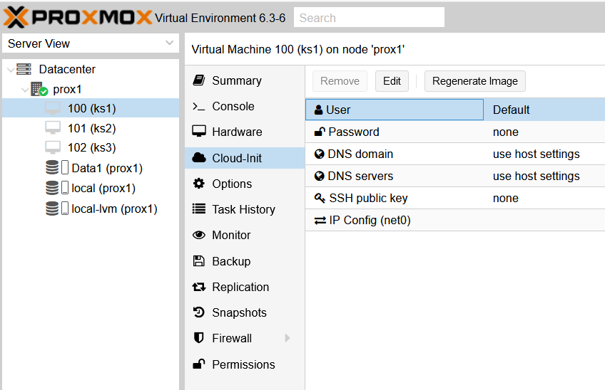  
   to get:  
   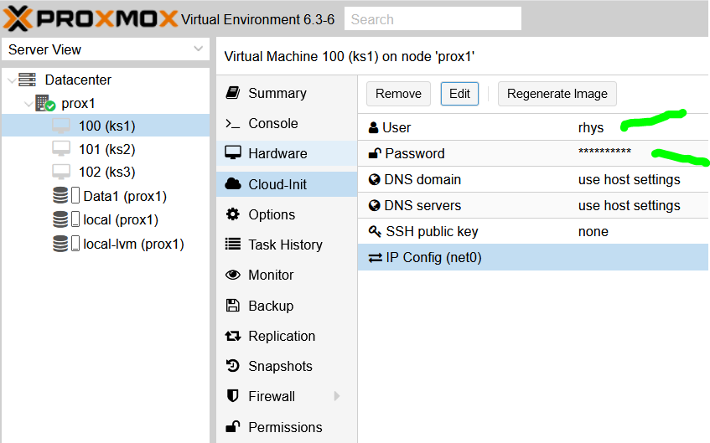
8. Now click on Regenerate Image
9. The VM template creation is now complete.
10. To **use the VM template**:
11. With the machine stopped, goto this screen, right click on the machine and click on clone:  
    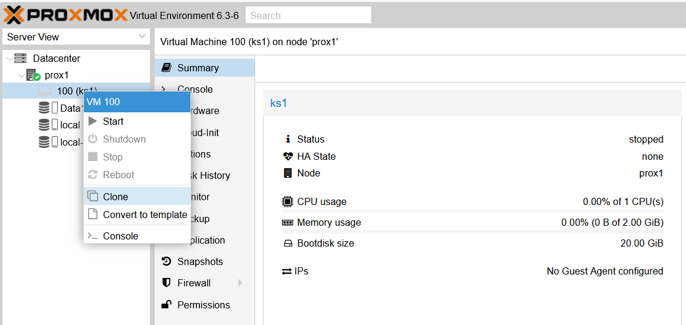  
    to get, and fill in the Name thus:  
    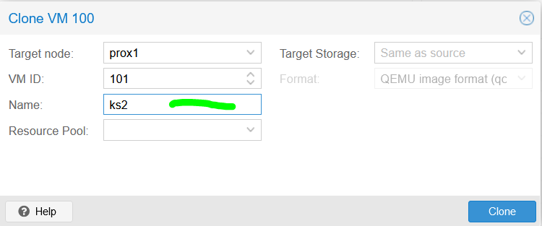
12. Click on Clone and a FULL clone after about a minute is created, thus:  
    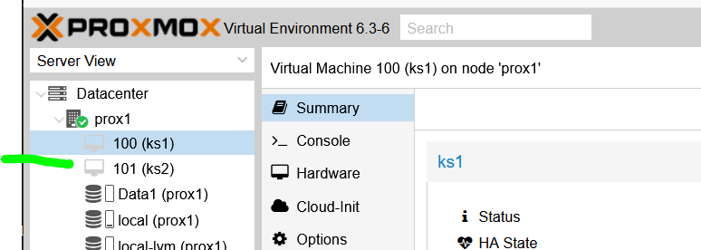
13. Repeat the cloning, to create ks3, thus:  
    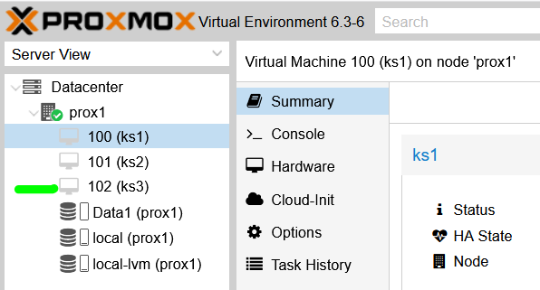
14. Boot up ks2
15. Log into it and follow the section above ”**Changing IP address …**”  
    to change the IP’s of the machines as follow:  
    192.168.124.**203**  
    Also edit / fix the **hostname** and **hosts** files in **/etc** to be **ks2**
16. Reboot the machine for the changes to take effect and when logged back in check that the hostname is correct and do:  
    ip add show  
    to confirm that the IP has changed and is correct.
17. Boot up ks3
18. Log into it and follow the section above ”**Changing IP address …**”  
    to change the IP’s of the machines as follow:  
    192.168.124.**204**  
    Also edit / fix the **hostname** and **hosts** files in **/etc** to be **ks3**
19. Reboot the machine for the changes to take effect and when logged back in check that the hostname is correct and do:  
    ip add show  
    to confirm that the IP has changed and is correct.
20. That completes setting up the 3 servers for kubernetes.

**Kubernetes install:**

1. See 30:45 mins in, in: <https://www.youtube.com/watch?v=qv3_gLvjITk>
2. Or K3s cluster video: ???

From ML1 Get Ansible script going to do the above … need an ssh key thing set up, document all steps